**Test Plan**

The purpose of the program is to calculate the number of days in a month with a user input month number and year number.

**Program Functional Requirements**

1. User needs to be prompted for a year and month input.
2. The program has to reject invalid integer inputs from the user
3. The program has to evaluate whether or not the year entered is a leap year.
4. The program has to return the number of days in the selected month, accounting for whether or not the year is a leap year as well because leap years have different values than non-leap years.
5. The program has to convert the month number entered into a month name (1 -> January).
6. The program has to output the month name entered has x days.

**Traceability Matrix**

|  |  |  |  |  |
| --- | --- | --- | --- | --- |
| Test Case | Input/Output | Expected Result | Actual Result | Outcome (p/f) |
| 1 | The user is prompted for a year and month input. | Enter a month in the year (e.g., 1 for Jan): Enter a year: | Enter a month in the year (e.g., 1 for Jan): Enter a year: | pass |
| 2 | 15 is entered for the month number | Enter a value 1-12 | Enter a value 1-12 | pass |
| 3 | -3000 is entered for the year number | Enter a positive int | Enter a positive int | pass |
| 4 | 2 is entered for the month number, 2012 is entered for the year number | February 2012 has 28 days | February 2012 has 28 days | pass |
| 5 | 2 is entered for the month number, 2014 is entered for the year number | February 2014 has 28 days | February 2014 has 28 days | pass |

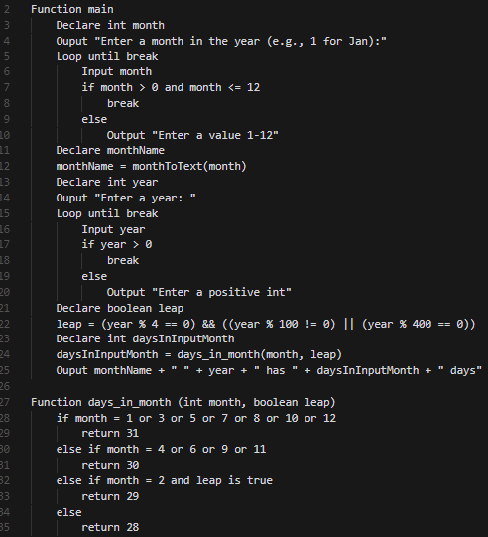

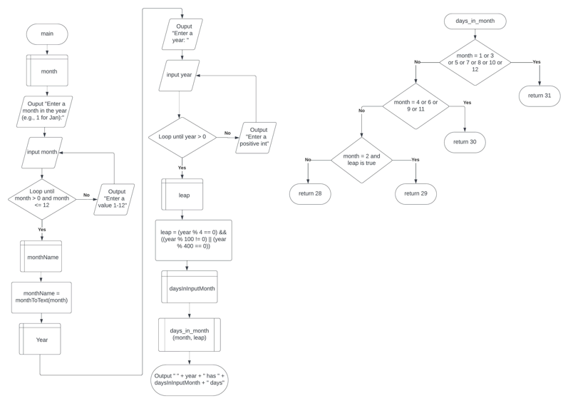

**Test Plan**

The purpose of this program is to calculate whether a user input set of coordinates are inside a rectangle of width 10 and height 5 centered on the middle of a coordinate grid.

**Program Functional Requirements**

1. User needs to be prompted for a x and y coordinate input
2. The program has to evaluate if the input coordinate is within the rectangle
3. If the coordinate is within the rectangle, the program must output “Point (x, y) is in the rectangle”.
4. If the coordinate is not within the rectangle, the program must output “Point (x, y) is not in the rectangle”

**Traceability Matrix**

|  |  |  |  |  |
| --- | --- | --- | --- | --- |
| Test Case | Input/Output | Expected Result | Actual Result | Outcome (p/f) |
| 1 | X input is 0, y input is 0 | Point (0.0, 0.0) is in the rectangle | Point (0.0, 0.0) is in the rectangle | pass |
| 2 | X input is 10, y input is 0 | Point (10.0, 0.0) is not in the rectangle | Point (10.0, 0.0) is not in the rectangle | pass |
| 3 | X input is 5, y input is 2 | Point (5.0, 2.0) is in the rectangle | Point (5.0, 2.0) is in the rectangle | pass |
| 4 | X input is 5, y input is 5 | Point (5.0, 5.0) is not in the rectangle | Point (5.0, 5.0) is not in the rectangle | pass |
| 5 | X input is 5.001, y input is 2 | Point (5.001, 2.0) is not in the rectangle | Point (5.001, 2.0) is not in the rectangle | pass |

